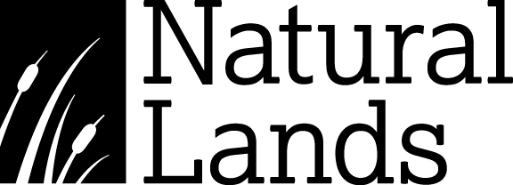

The health and safety of all Natural Lands visitors, volunteers, and staff is our first priority.

In an abundance of caution and in light of the current coronavirus COVID-19 outbreak, all buildings and restrooms at this preserve will be closed to the public until further notice.

We apologize for the inconvenience.

You can stay up-to-date on Natural Lands’ response during this public health crisis by visiting natlands.org/covid19, which we will update as the situation evolves.

Thank you for your understanding.