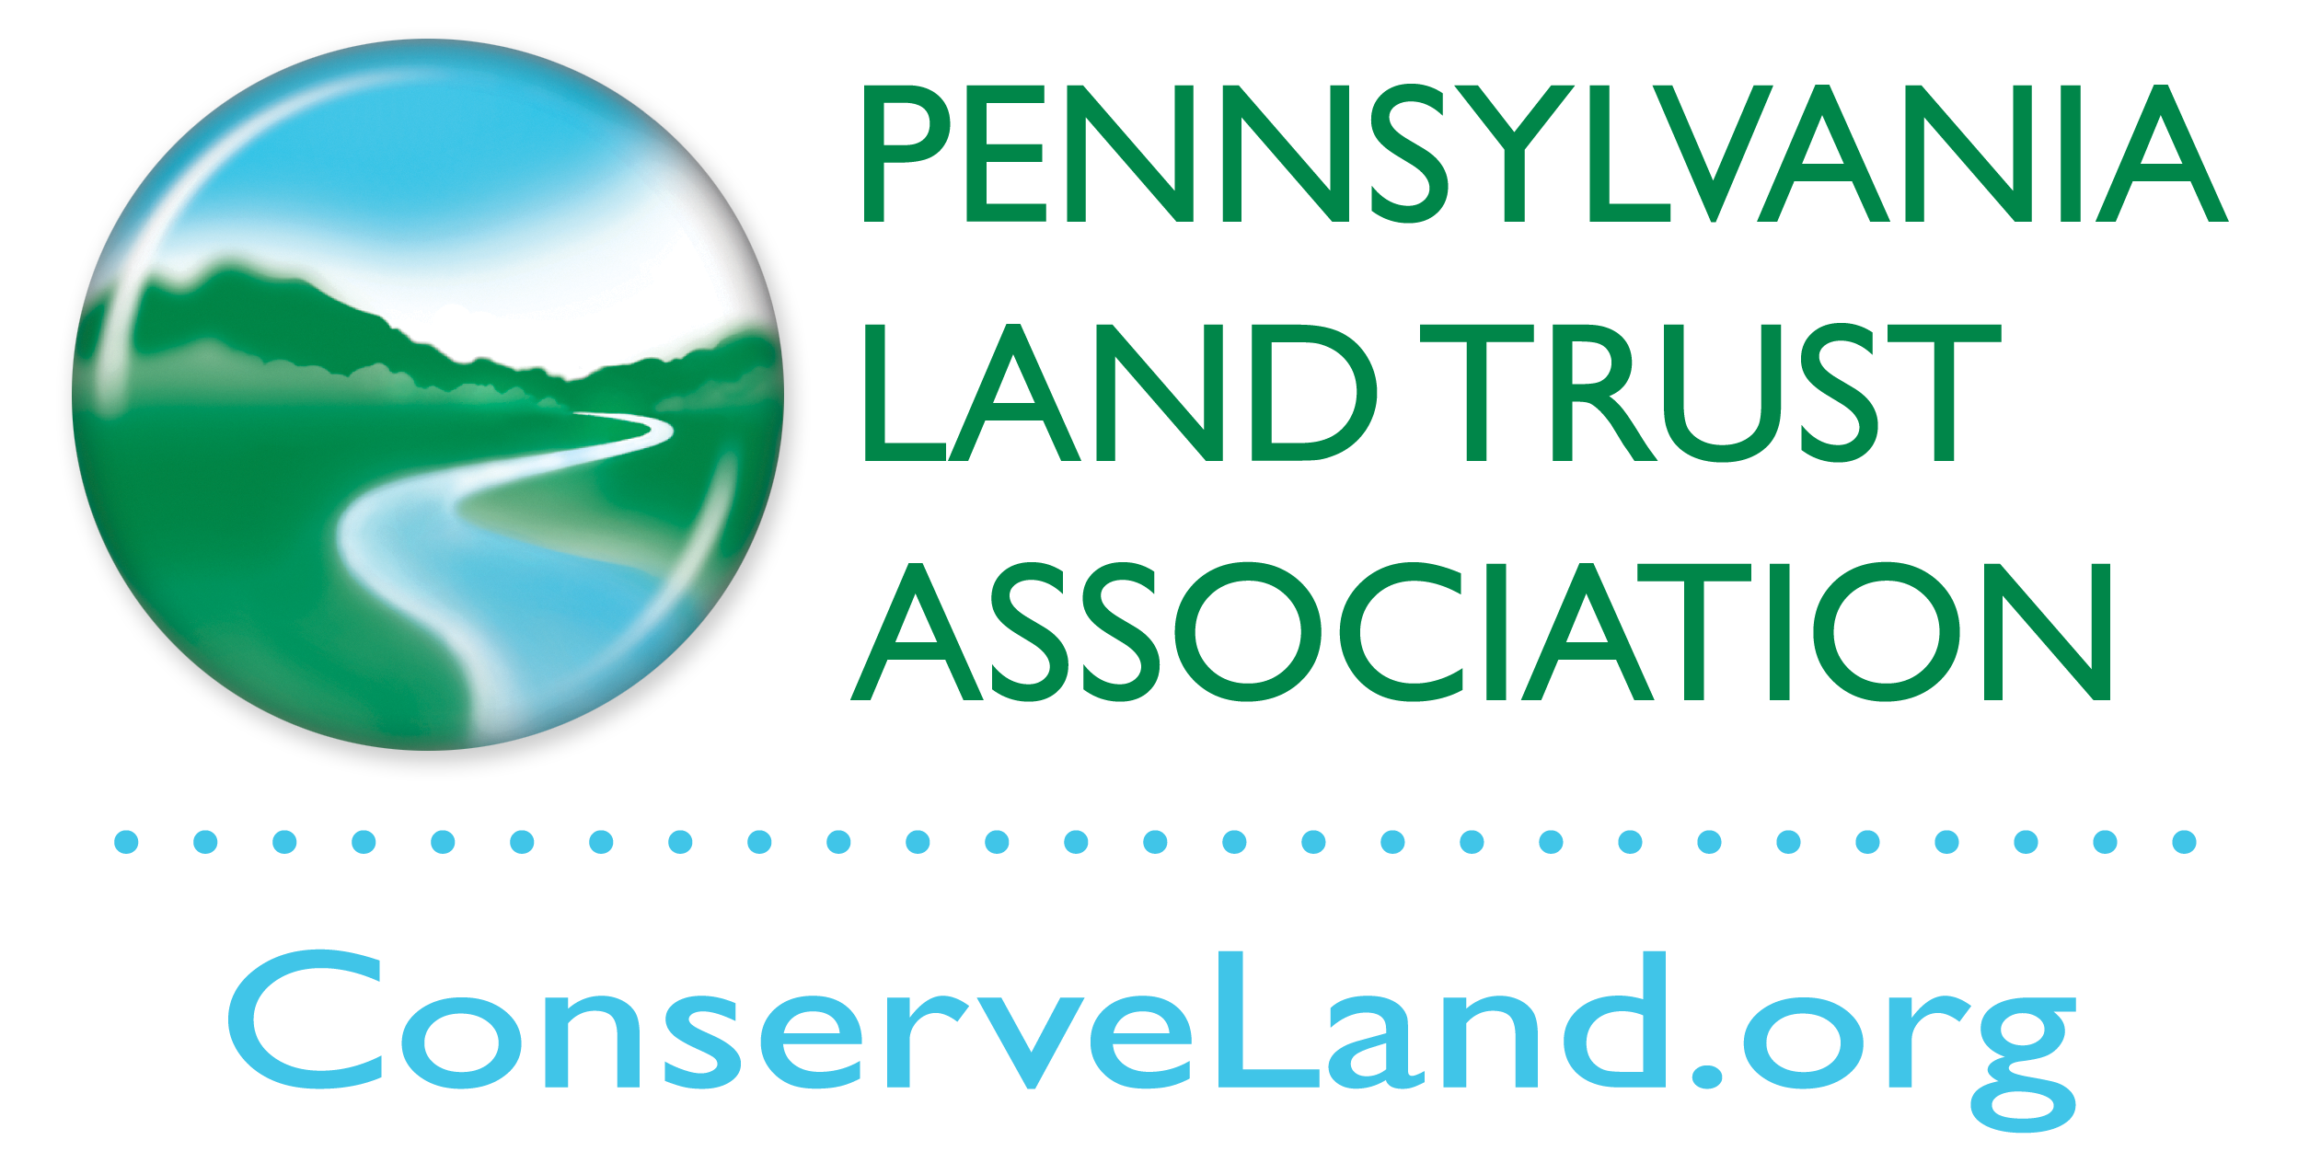

119 Pine Street, 1st floor

Harrisburg, PA 17101

717 230-8560

info@conserveland.org

## 2019 Membership Dues Invoice

Please mail this form with check made payable to the *Pennsylvania Land Trust Association*. Questions? Call us at (717) 230-8560.

**Guideline: 1% of your organization’s annual budget for land conservation operations**

**Organization Name:**

 $1500

 $2000

 $2500

 $3000

 $3500

 $4000

 $5000

(maximum)

**Select Contribution Level:**

 $210 *minimum*

 $300

 $400

 $500

 $600

 $800

 $1000

 $1200

$ ________ Additional contribution

**$ ________ TOTAL**

**Contact Person:**

**Street Address:**

**City: State: Zip:**

 **In the future, please send this invoice to the following individual, if different than above:**

**________________________________________**

 **In the future, please send this invoice to the following mailing address, if different than above:**

**________________________________________**

**________________________________________**

**________________________________________**

**________________________________________**

**Please attach a list of your current board members (including: full name, title, mailing and email addresses) with this form.**

*Board members and active volunteers of member organizations are entitled to receive PALTA’s publications and e-mails, including the ConserveLand newsletter at no charge.*

*Regular voting membership is open to nonprofit organizations who support PALTA’s goals and who: acquire land or conservation easements for conservation purposes;* ***or*** *provide stewardship of land or conservation easements;* ***or*** *assist organizations in accomplishing land trust work;* ***or*** *generally advance the cause of land and water conservation.*

*Government agencies, businesses, individuals, and others may join as Associate (non-voting) Members.*

 *Check here only if you believe you should be or wish to be classified as an Associate (non-voting) Member.*