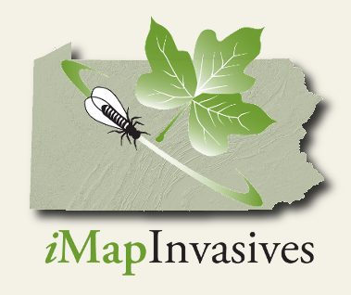

Interested in learning more about Pennsylvania *i*MapInvasives? Check out our BRAND NEW homepage!

[www.naturalheritage.state.pa.us/paimap.aspx](http://www.naturalheritage.state.pa.us/paimap.aspx)

Funding for *i*MapInvasives is provided by the Great Lakes Restoration Initiative

PNHP is the Lead Partner Organization for PA *i*MapInvasives

